ROYAL FOODS

Trusted Food Service Partner for Educational Institutions
About Us
ROYAL FOODS is a professionally managed food service company with over 25+ years of excellence in institutional catering and large-scale food operations.
With a strong commitment to quality, hygiene, and customer satisfaction, we proudly provide healthy and nutritious meals to approximately 2200–2500 students at MIT ADT University.
Over the years, ROYAL FOODS has earned a reputation for delivering reliable, hygienic, and professionally managed food services for educational institutions. Our expertise lies in handling large-volume catering operations while maintaining consistency in taste, nutrition, and service standards.
We believe that good food plays an important role in student health, productivity, and overall well-being. Therefore, every meal we serve is prepared with quality ingredients, proper hygiene practices, and a focus on balanced nutrition.

Director’s Message


Message from the Director

Shri Ravindra Vitthal Deshmukh
“At ROYAL FOODS, our mission has always been to provide safe, hygienic, nutritious, and quality food with complete dedication and professionalism.
For more than 25 years, we have continuously worked towards maintaining high standards in institutional catering services. Serving thousands of students every day is not just our responsibility, but also our commitment towards their health and satisfaction.
We strongly believe that quality food and excellent service create a positive and healthy environment for students and institutions alike. Our team remains dedicated to continuous improvement, operational excellence, and customer satisfaction.
We sincerely thank our clients and partners for their trust and continued support.”
Shri Ravindra Vitthal Deshmukh
Director
ROYAL FOODS

Why Choose ROYAL FOODS?

✔ 25+ Years of Experience
Decades of expertise in institutional catering and food service management.

✔ Trusted by Educational Institutions
Successfully serving large student communities with efficiency and consistency.

✔ Large-Scale Daily Operations
Capable of serving meals to 2200–2500 students every day.

✔ Hygiene & Food Safety
Strict hygiene protocols and quality control measures at every stage of food preparation.

✔ Nutritious & Balanced Meals
Well-planned menus designed to provide healthy and satisfying meals.

✔ Experienced & Professional Team
Skilled kitchen staff, disciplined operations, and efficient service management.

✔ Timely & Reliable Service
Commitment to punctual meal delivery and smooth dining operations.

✔ Customer Satisfaction Focus
Dedicated to maintaining high service standards and long-term relationships.

Our Services
- Hostel Mess Management
- College & University Catering
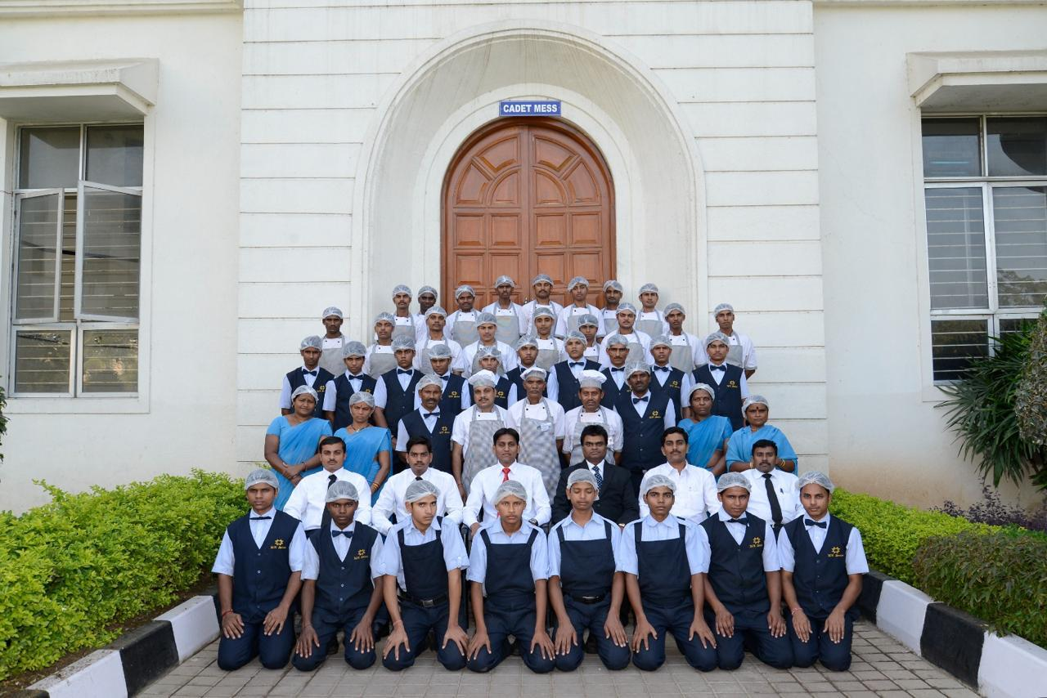
- Breakfast, Lunch & Dinner Services
- Institutional Food Services
- Event & Seminar Catering
- Bulk Food Supply
- Hygienic Kitchen Operations
- Customized Meal Planning

Our Operational Strength
Category | Details
Industry Experience | 25+ Years
Daily Serving Capacity | 2200–2500 Students
Core Specialization | Institutional Catering
Focus Areas | Hygiene, Nutrition & Quality
Service Commitment | Timely & Professional
Client Segment | Educational Institutions

Our Commitment to Quality
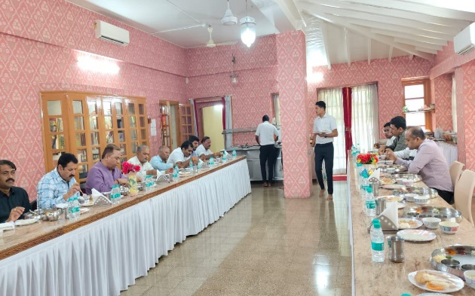
At ROYAL FOODS, quality is the foundation of everything we do. We ensure:
- Fresh and quality ingredients
- Clean and hygienic cooking environment
- Balanced and nutritious meal planning
- Regular quality checks and supervision
- Consistent taste and food standards
- Professional staff training and discipline

Our Mission
To deliver hygienic, nutritious, and high-quality food services with professionalism, consistency, and customer satisfaction.

Our Vision
To become the most trusted and preferred institutional catering partner by maintaining excellence in food quality and service standards.

Contact Us…

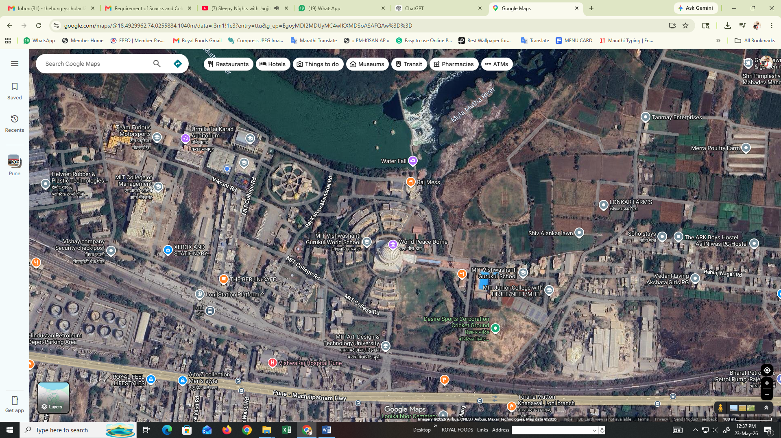
ROYAL FOODS



PUNE-SOLAPUR HIGHWAY

📍 MITADT University, Loni Kalbhor Pune, Maharashtra, India 412201
👤 Director: Shri Ravindra Vitthal Deshmukh
📞 +91-9822080115, 7057450842
📧 royalfoods8@email.com

Healthy Food • Quality Service • Trusted Experience

